Nicholas Jurgens

James McKenna

Mark Ramalingam

TIM 165 Project: The UCSC TAPS Parking Problem

**Sections**

***1. Abstract***

The goal of this research project is to derive an answer to the question of whether the UC Santa Cruz Transportation and Parking Services (TAPS) should create another multi-tiered or flat parking lot to accommodate the increase in car traffic on campus. Using the decision analysis process we solved this complex problem and created a decision making strategy. We have concluded that the optimal decision strategy is to construct an additional flat lot, which will yield the same profit as having not done anything.

***2. Background***

As UCSC enrollment increases annually, the number of off-campus students who need to commute to campus increases. The current parking situation is already over capacity with remote parking lots permits selling out within the first 48 hours, and a long waiting list which is never satisfied. These unsold permits are lost potential revenue to the University. The solution is to develop a long term plan to construct additional parking lots or structures requiring a certain square footage per space, while maximizing the profit.

Profit, in the context of this decision, is the ability for projected parking permit sales to pay for the initial construction costs of additional spaces. The alternatives are as follows: construct an additional new flat parking lot, expand vertically on a current parking lot, or do nothing and wait for more information. This problem is further complicated by the fact that UCSC is sitting on a complex network of caves crossing through a limestone shelf. This will only affect the expansion decision since the parking lot would be constructed on new unsurveyed land.

***3. Method***

We will be creating decision trees and diagrams in order to determine which set of choices, based on our data, will maximize available parking spots for students. In the process of designing the decision tree we will be taking into consideration the following uncertainties: projected enrollment of graduate and undergraduate students, number of core samples needed, and the number of students parking on campus.

Each of these uncertainties will factor into determining the end profit and EMV of each strategy. We will also be looking at the lost capital from unsold permits and the sunk costs associated with building additional lots. Unsold permits include those on the waitlist as well as any excess spots that may result from overbuilding. It’s important to note that we will only be taking into consideration R permits when performing our decision analysis.

In summary, the context of the decision can be identified with the following elements:

Objectives:

1. Maximize the profit to UCSC from parking permits which are sold

Alternatives:

1. Construct an additional new flat parking lot

2. Expand vertically on a current parking lot

3. Do nothing and wait for more information

Uncertainties:

1. Projected enrollment of graduate and undergraduate students

2. Number of core samples needed

3. Number of students parking on campus

Consequences:

1. Lost capital from unsold permits

2. Sunk costs associated with building additional lots

***4. Data***

To obtain a majority of our data we set up an interview with Larry Pageler, the Director of Transportation and Parking Services for UCSC. In our meeting we were able to discuss the current parking situation for UCSC, and specifically which factors we should consider when making this decision. He was able to provide us with a rich data set of all the permit transactions that occurred within the school year of 2016-2017. By filtering for R-permits and removing any duplicate transactions, we were left with an accurate dataset that we could use for our decision analysis (Figure 1).

*Figure 1: (FALL 2017 Parking Extract) Filtered for our problem.*

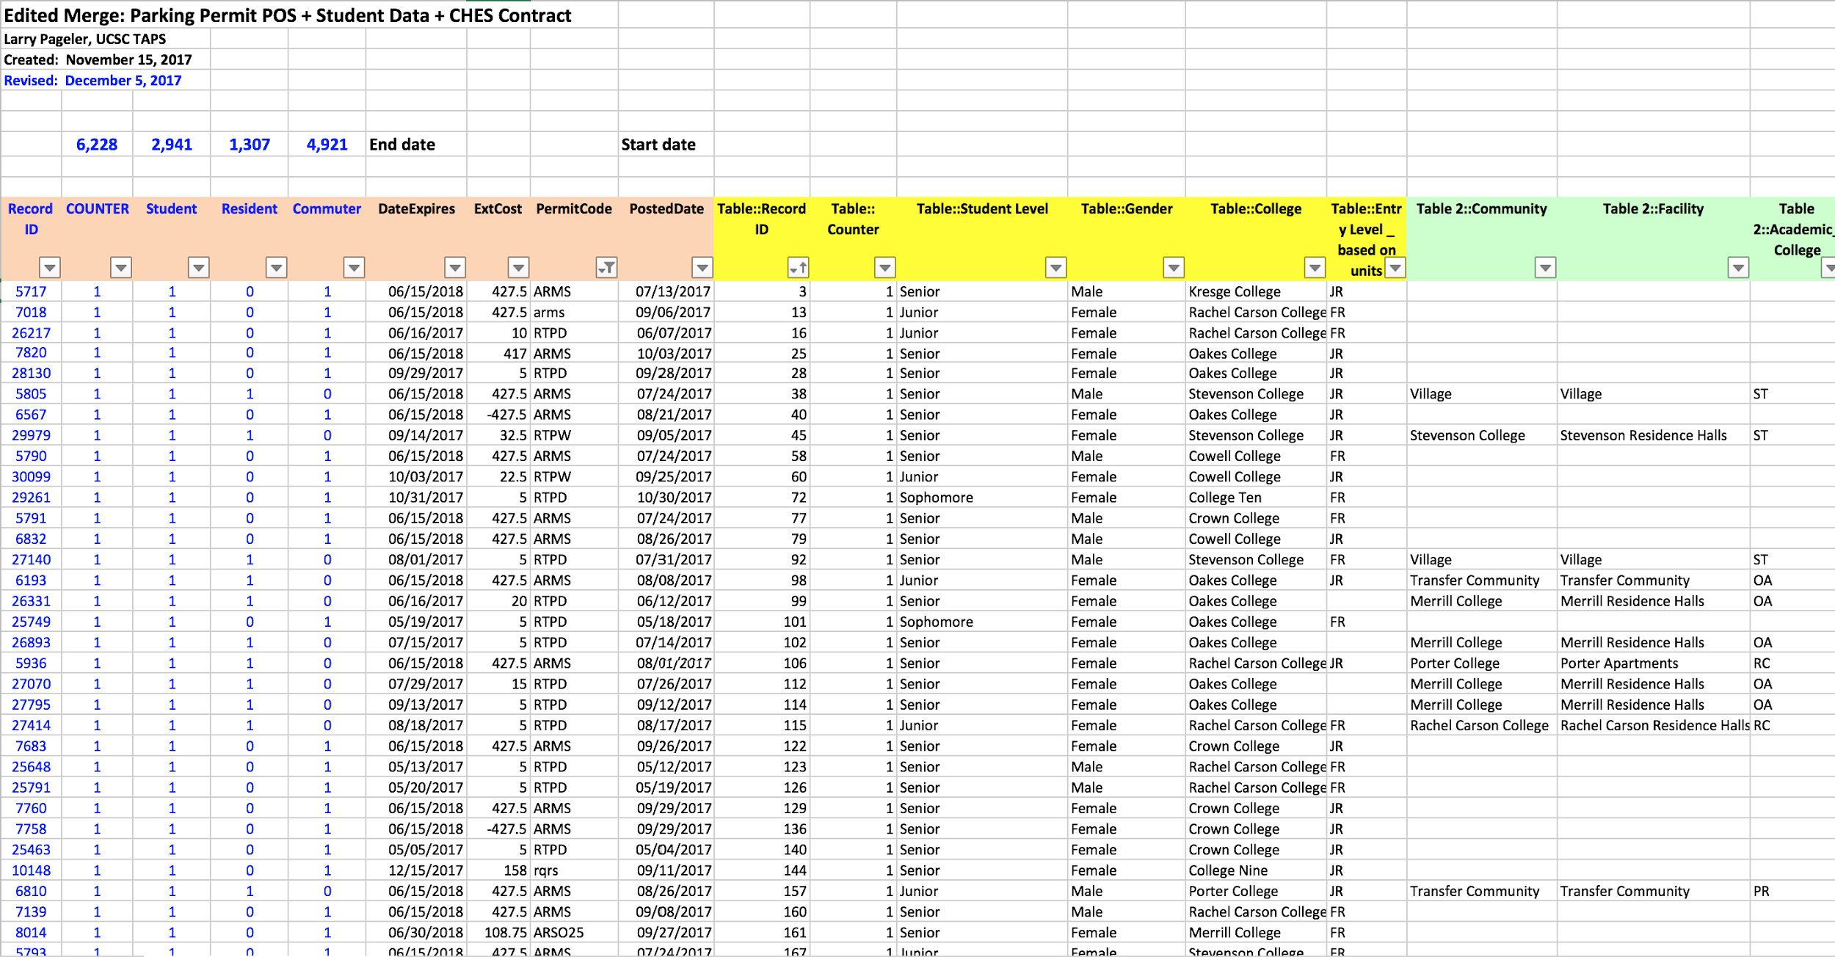

We also used online resources to further strengthen our dataset. This includes the following: constructions planning costs, linear regressions, costs of permits, transportation methods, enrollment totals, and parking lot costs. The reference for these are included at the end of the report.

***5. Execution***

After gathering all of the necessary information, we began with creating an influence diagram (*Figure 2)*. The diagram begins with the overarching decision, “Should we build a parking structure?”. This decision node includes the three alternatives of build, expand, and do nothing.

*Figure 2: Influence Diagram*

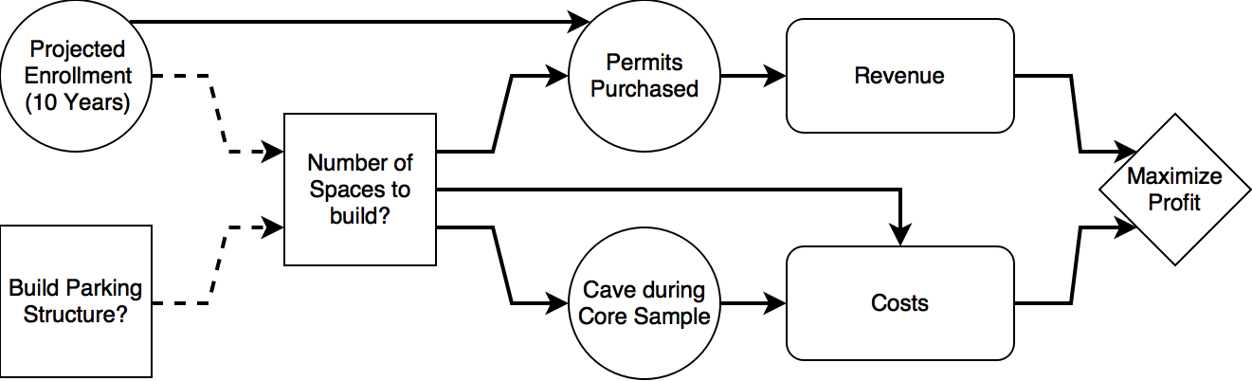

The decision must be made before deciding on the number of spaces to build for the parking lot. The number of spaces is also made after knowing the projected enrollment for the upcoming school years. Making this second decision is relevant to assessing the probabilities of the outcomes for permits purchased and hitting a cave during a core sample. Permits purchased is also influenced by the projected enrollment. Subsequently, revenue is decided by the amount of permits purchased. On the bottom end of the influence diagram the total cost is computed by the sum costs of the number of spaces built and the amount of core samples performed. Finally, the revenue and cost feed into the consequence node “maximize profit”.

After constructing the influence diagram, we had an idea of what decisions and changes were influenced by one another and what would ultimately influence the final consequence. Our next step was to create a decision tree, allowing us to analyze the best decision path. Because our tree was so extensive, we had to break it up into the three different alternatives: build, expand, and do nothing (*Figure 3)*.

*Figure 3: Decision Tree: Build, Expand, Do Nothing*

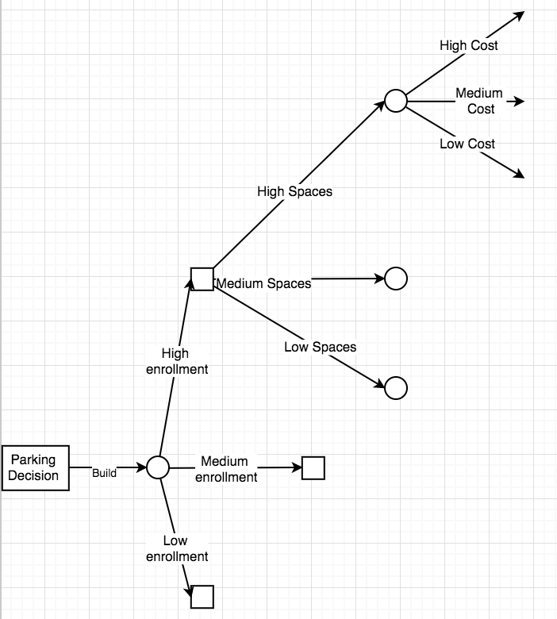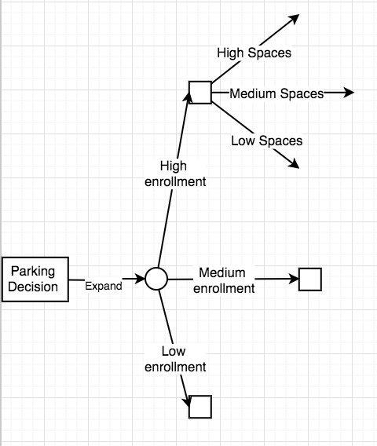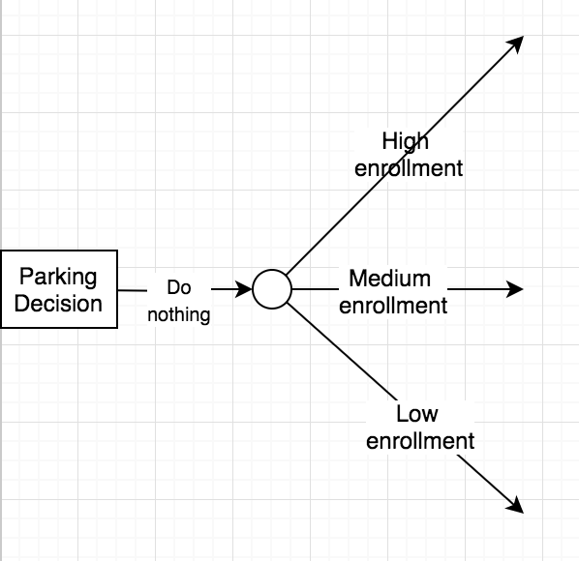

The first tree consists of constructing an additional new flat parking lot. Due to building on new land, we would have to include the chance node of taking core samples to allocate space for the new lot. The second tree is for expanding vertically on a current parking lot. This tree doesn’t require the core samples but the average cost of building a space increases significantly. Lastly, the third tree is to do nothing and wait for more information. However, the downside is that there will be lost potential revenue from unsold permits over the next 10 years. Combining this tree allows us to solve for the total amount of strategies for this decision tree. The total amount of strategies is equal to

After creating the decision tree, we started to solve for the EMV of each decision. To begin this process, we started by looking at the 2016-2017 permit sales (*Figure 4).* By looking at Figure 4 we can see that 2,941 individual students currently buy any type of R permit during the school year.

*Figure 4: Permit Sales*

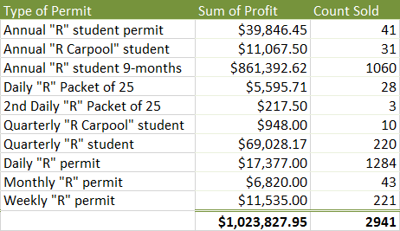

Currently there are an approximately 300 additional students who want permits that can’t get them because the lots would be over capacity. This information was provided by TAPS. Taking the sum profit made, $1,023,827.95, we divided by the number of permits sold to find the average sale for a student. This results in the following . This suggested that UCSC was missing an annual revenue of $104,400 (. However, this did not include the missing annual revenue as a result of enrollment fluctuation. To account for this we looked at the student enrollment data (*Figure 5).*

*Figure 5: Student Enrollment*

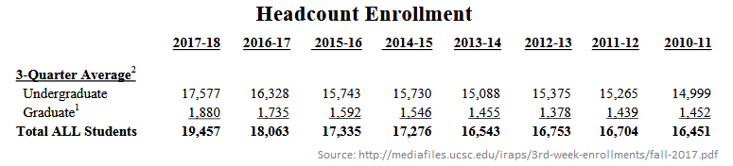

For the year 2017-18 the student enrollment total was 19,457. Given that only 2,941 bought permits, this means that only 15.12% ( of the total student population had an R permit. We looked at the average enrollment increase over the last 7 years to make a best guess estimate of the projected future enrollment using a linear regression. By taking the values and solving for the slope of the line starting at 15,700, we used the formula for regression and minimize the mean square error. The resulting equation of gave the estimated enrollment *x* years after 2010 with the following graph.

*Figure 6: Regression line of Estimated Enrollment*

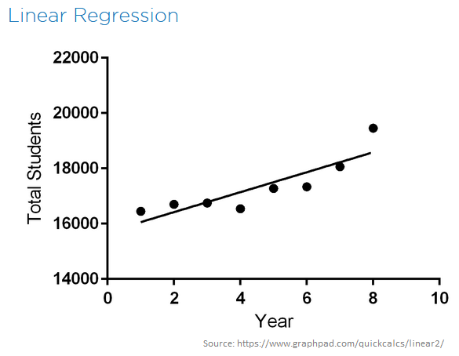

We can see from the line that there may be an upward trend in the last 4 years as enrollment beings to spike upward. We used our initial estimation of 361 new students per year to determine lost potential revenue but there is a question of exponential enrollment which would exacerbate the problem of insufficient parking.

In our analysis we included the sensitivity for the student enrollment growth, estimated to be low, base, and high of the suggested value of 361. The standard deviation from the mean value was 100.8, so by using a normal distribution (*Figure 7*) we calculated a 15.9% chance for higher enrollment growth and 15.9% chance for a lower enrollment growth.

*Figure 7: Normal Distribution with Standard Deviations*

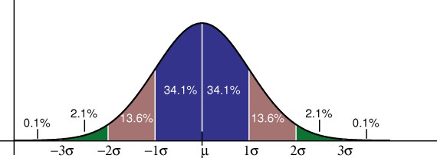

By using Excel we created a spreadsheets of all possible values given the expected costs and profits for each decision branch. There were 39 possible outcomes with an expected annual profit over 10 years and 24 years. 10 years would include the reasonable projection for student enrollment growth without knowledge beyond the scope of the regression. 24 years was duration of the TAPS long-range plan and in our decision is the estimated time that a parking structure should be repaid by permit sales.

To predict the cost of performing core samples in the case of building a parking lot on new unsurveyed land, we used a Bernoulli trial probability to estimate the risk of hitting a cave based on the size of the proposed lot. The core samples must be performed at every 25 feet, so a 25 square foot area would have 4 total core samples. Research revealed that the average cost of performing a single core sample is $960. The square foot sizes of each lot and the number of samples needed will determine the costs for respective lots as seen in Figure 8.

*Figure 8: Average Sampling Costs*

|  |  |  |  |
| --- | --- | --- | --- |
| **Spaces** | **Low (250)** | **Medium (500)** | **High (1400)** |
| Square Feet | 40,500 | 81,000 | 226,800 |
| Core Samples Needed | 65 | 130 | 363 |
| Sampling Cost | $62,206 | $124,416 | $348,365 |

Bernoulli trial probability with an estimated 0.005 chance of contacting a cave on each sample gave the probabilities shown in Figure 9.

*Figure 9: Restarted Site Sampling Risk*

|  |  |  |  |
| --- | --- | --- | --- |
| **Spaces** | **Low (250)** | **Medium (500)** | **High (1400)** |
| P(Low) 1 Site | 0.72 | 0.52 | 0.16 |
| P(Medium) 3 Sites | 0.17 | 0.36 | 0.34 |
| P(High) 5+ Sites | 0.11 | 0.12 | 0.5 |

Using this data would give an estimated overall cost of performing core samples and whether the process must be started at a new site. For example there is a 50% probability that the core sampling costs would be in attempting to build a large 1400 space lot.

The completed decision tree in Excel (*Figure 10*) shows these 39 outcomes and the variables which were used to make our determinations.

*Figure 10: Decision Tree Outcomes*

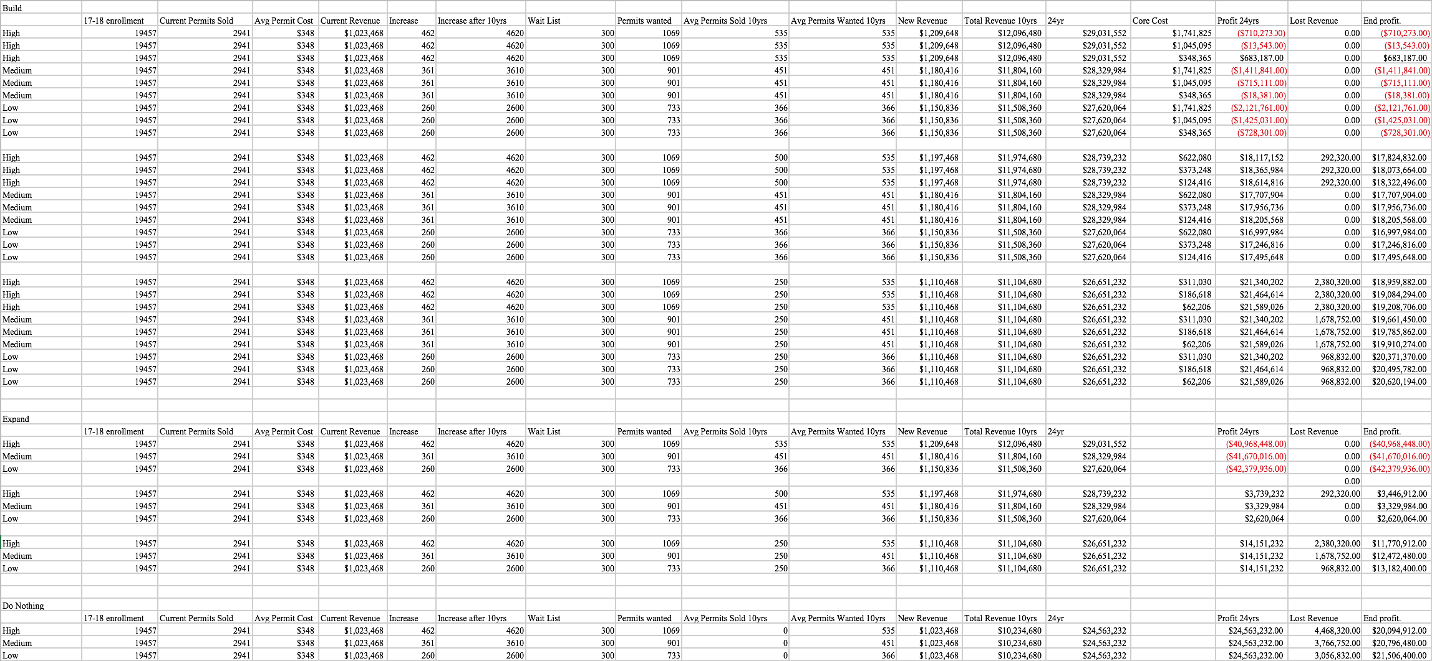

The first branch is the decision to build an entirely new lot, as seen below:

*Figure 11: Expected Monetary Value of Building a New Lot*

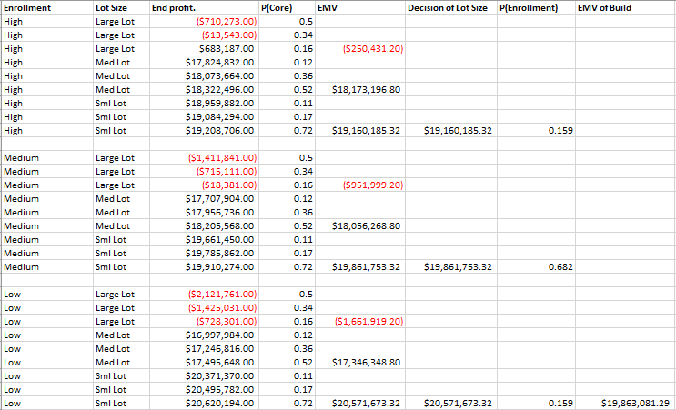

Building a completely new parking structure given the varying student enrollment sizes and whether we decide on a small, medium or large density parking lot gives an EMV of $19.86 million. Building a large 1400 space parking lot will result in a negative EMV 8 out of 9 times, the exception being a high enrollment and first core sampling site success. The probability of this outcome is only 2.5%. This tells us that after 24 years, the school will still be in debt and will not have broken even with the build project. Building a medium density or low density lot on the other hand will result in a positive EMV over the 24 year time period, because of the low risk of having expensive core sampling.

In the case of the school having a medium enrollment class, building a large lot will result in a negative EMV, also putting the school into debt after the 24 year period. However, building medium density or low density lots will result in a positive EMV. Lastly, if we expect a low enrollment class at UCSC then it follows that building a high density parking lot will result in a significantly negative EMV, building a medium density lot results in a positive EMV and building a low density lot will result in the highest EMV in the whole chart (which makes sense seeing as we are properly accommodating our student enrollment).

*Figure 10: Expected Monetary Value of Expanding an Existing Lot*

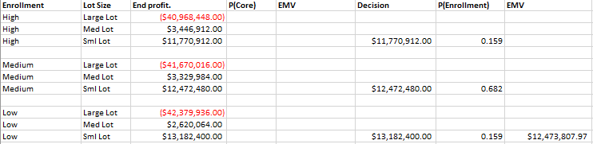

Expanding an existing lot is a little different as we do not have to account for the cost of drilling core samples to determine ground stability because these are pre-existing structures and have already had ground testing. We would be expanding one of three lots, East Remote Parking, West Remote Parking or North Remote Parking. Out of these decisions, the ones that would maximize EMV include: expanding the North Remote lot by 250 spaces given high student enrollment, medium student enrollment, or low student enrollment.

*Figure 11: Expected Monetary Value of Doing Nothing*

**

If we kept parking space quantity constant and let permit prices fluctuate according to the market, we wind up with the highest expected monetary value of $20.80 million. It makes sense as we do not have to account for high construction costs and professional staff to oversee operations, and we would not have additional geotechnical core testing costs for structural stability. If we want to maximize expected monetary value we should simply not construct additional spaces or build a new structure.

***Conclusion***

*Figure 12: Concluding Results*

|  |  |
| --- | --- |
| **Decision** | **EMV** |
| Build New Parking Lot | $19,863,081.29 |
| Expand on Existing Lot | $12,473,807.97 |
| Do Nothing | $20,797,807.97 |

The decision to build an additional flat parking lot has roughly the same expected profit as doing nothing over a 24 year time span. Additional values put into consideration, the problem suggests that our best course of action would be to construct an additional parking lot. If we take into account the satisfaction of students, the end decision may add some weight to building a new parking lot. Doing nothing and building a new lot produce about the same profit over a 24 year period.

However we must take into consideration the utility of enrolled students. Our main objective is to maximize expected monetary value but only to pay for the costs of the structure. Morso the objective it is to maximize the utility to enrolled students who rely on on-campus parking. If we have dissatisfied students it may even result in lower enrollments per year and result in incremental losses in profit in permit sales.

***References***

Constructions Planning:

https://taps.ucsc.edu/pdf/TAPS-funding-and-expenditures.pdf

Linear Regression:

https://www.graphpad.com/quickcalcs/linear2/

Cost of Permits:

https://taps.ucsc.edu/pdf/parking-fees-2016-2019.pdf

Transportation Method:

https://sustainability.ucsc.edu/topics/files/ucsc-assessment-transportation.pdf

Enrollment Totals:

http://mediafiles.ucsc.edu/iraps/3rd-week-enrollments/fall-2017.pdf

Parking Lot Cost:

a.streetsblog.org/2014/10/17/new-ca-database-shows-how-much-parking-costs